HIPO Charts: Evan

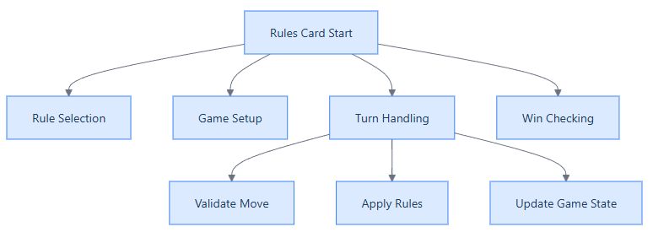

 | Input | Process | Output
Rule Selection | Player choice/buttons | Enable selected rules | Chosen ruleset
Game Setup (1) | Chosen ruleset | Configure game | Initial game state
Game Setup (2) | Player hand | Shuffle deck | Draw cards
Validate Move | Player action | Check rules | (In)Valid move
Apply rules | Active rules | Apply rules | Update game state
Update Game State | Game state | Update turn | Next turn
Win checking | Game state | Check win condition | Detect win / not win

